**T.C.**

**MANİSA CELAL BAYAR UNIVERSITY**

**FACULTY OF ENGINEERING**

**COMPUTER ENGINEER DEPARTMENT**

**Radio Emergency**

**Computer Design II**

**PREPARED BY**

**130315035 – İLKER ÜNAL**

**ADVISOR**

**ÖVÜNÇ ÖZTÜRK**

**MANİSA 2018**

**T.C.**

**MANİSA CELAL BAYAR UNIVERSITY FACULTY OF ENGINEERING COMPUTER ENGINEER DEPARTMENT**

**Computer Engineering Design II**

**ACCEPTANCE AND APPROVAL DOCUMENT**

**Computer Engineering Design "Radio Emergency" was evaluated and accepted by the jury created below.**

Advisor : Asst. Assoc. Dr. Övünç ÖZTÜRK Member : Assoc. Dr. Tuğba ÖZACAR ÖZTÜRK Member : Asst. Assoc. Dr. Didem ABİDİN Member : Asst. Assoc. Dr. Birim BALCI

The Day the Project is Defended: 08/06/2018

Head of Computer Engineering Department

-------------------------------------------------

**TABLE OF CONTENTS**

Sayfa

FIGURE LIST 4

1. INTRODUCTION 5

1.1 Why do we need a Portable - Dynamic FM Radio station ? 5

1. COMPONENTS AND TOOLS 6
   1. 2.1 Arduino6
   2. 2.2 FM Transmitter Module7
   3. 2.3 LCD Display8
   4. 2.4 Potentiometer 9
   5. 2.6 Voice Recording Module10
   6. 2.7 Code Explanation11
2. CONCLUSIONS  10

LIST OF FIGURES

Figure 1.1 Radio Emergency Logo

Figure 2.1 Arduino Logo and Arduino Board

Figure 2.2 Elechouse FM Transmitter Module  
Figure 2.3 Nokia 5110 LCD Display

Figure 2.4 Potentiometer

Figure 2.5 ISD 1820 Voice Recorder Module

Figure 2.6 Arduino Pin Diagram

1. INTRODUCTION

**1. Why would we need a “Dynamic FM Radio Station” ?**

In order to give a proper answer for this question, firstly we need to know “ What is radio” and “ What is a radio station and in which areas do we use it?”.  
  
 Radio is the technology of using [radio waves](https://en.wikipedia.org/wiki/Radio_wave) to carry information, such as [sound](https://en.wikipedia.org/wiki/Sound), by systematically [modulating](https://en.wikipedia.org/wiki/Modulation) properties of electromagnetic energy waves transmitted through space, such as their [amplitude](https://en.wikipedia.org/wiki/Amplitude), [frequency](https://en.wikipedia.org/wiki/Frequency), [phase](https://en.wikipedia.org/wiki/Phase_(waves)), or [pulse width](https://en.wikipedia.org/wiki/Pulse-width_modulation).  
  
 A radio station is a set of equipment necessary to carry on communication via radio waves. Generally, it is a receiver or transmitter, an antenna, and some smaller additional equipment necessary to operate them.

Radios are everywhere, with at least 75% of households in developing countries having access to a radio. There are about 44,000 radio stations worldwide and everyday, the number increases.

When I examine the statistical data, I came up with the conclusion that the radion is a living technology today. Radio is a easily accessable communication device by everyone which is used in workplaces, cars and homes and everywehere else. For this reason, I decided to use radio in emergency cases.  
  
 My idea is using a Portable-Dynamic FM Radio Transmitter in emergency vehicles such as ambulances, firetrucks, police cars etc. to inform the people about the emergency cases to provide security and conscious behavior.



**

*Figure 1.1 Radio Emergency Logo*

2- COMPONENTS / TOOLS

**2.1- Arduino**

[Arduino](http://arduino.cc/) is an open-source platform used for building electronics projects. Arduino consists of both a physical programmable circuit board (often referred to as a [microcontroller](http://en.wikipedia.org/wiki/Microcontroller)) and a piece of [software](http://arduino.cc/en/Main/Software), or IDE (Integrated Development Environment) that runs on your computer, used to write and upload computer code to the physical board.

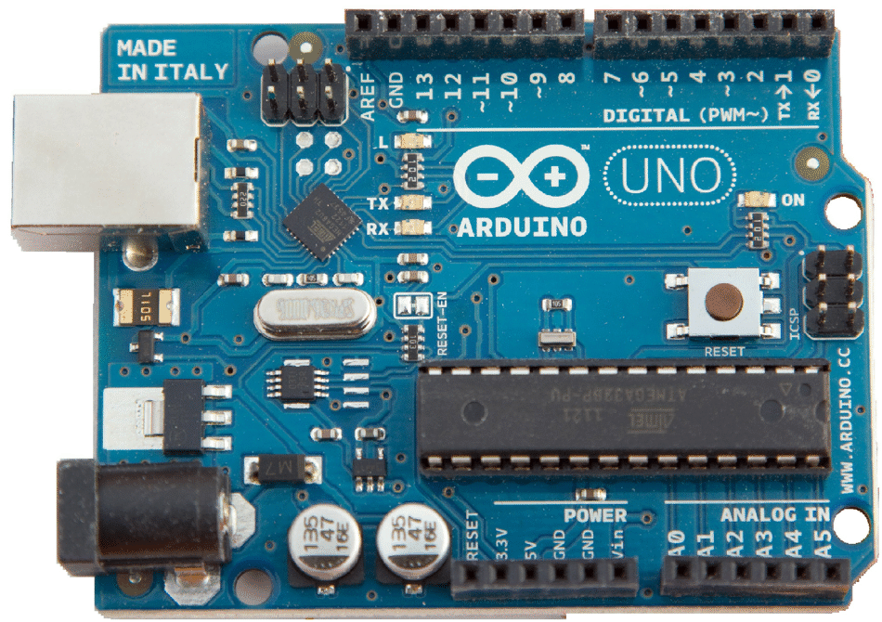



*Figure 2.1 Arduino Logo and Ardunio Board*

In our project, we used Ardunio to connect devices to each other and program them to transmit radio signals through the FM transmitter. We also connected a LCD Display to monitor the current frequency and a potentiometer to adjust frequency into an individual channel by manııally.

.

**2.2 – FM Transmitter Module**

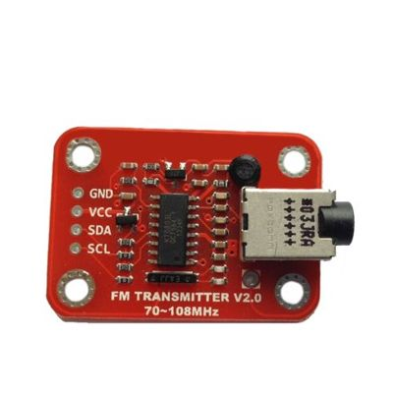

*Figure 2.2 Elechouse FM Transmitter Module*

An FM [radio transmitter](http://www.progressive-concepts.com/products/transmission-equipment/fm-transmitters.html) consists of several pieces that work together to transmit information (in the case of radio broadcasting, sound is that information). A typical FM radio broadcast transmitter that is used in FM broadcasting contains the following components:

* The power supply provides an electrical signal to operate the transmitter.
* The oscillator creates the alternating current, a carrier wave, that the transmitter sends through the antenna.
* The modulator adds information to the carrier wave. In the case of FM (frequency modulation), the modulator either slightly increases or decreases the frequency of the carrier wave.
* The amplifier increases the power of of the wave. More powerful amplifiers allow for a larger broadcast area.
* The last one, antenna converts the amplified signal to radio waves.

While the components of an FM radio transmitter may seem confusing to some, they are actually quite simple. Radio transmitters are used in a variety of applications, from radio and TV to electronic devices, such as wireless internet routers, and they are often built in schools as a project for science or electronics classes. These types of transmitters, however, are far less powerful than those that power your favorite FM radio stations.

**2.3 – LCD Display – Nokia 5110**

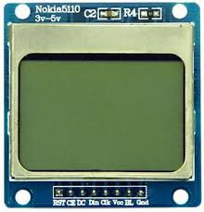To establish a good communication between human world and machine world, display units play an important role. And so they are an important part of embedded systems. Display units - big or small, work on the same basic principle. Besides complex display units like graphic displays and 3D dispays, one must know working with simple displays like 16x1 and 16x2 units. The 16x1 display unit will have 16 characters and are in one line. The 16x2 LCD will have 32 characters in total 16in 1st line and another 16 in 2nd line. Here one must understand that in each character there are 5x10=50 pixels so to display one character all 50 pixels must work together. But we need not to worry about that because there is another controller (HD44780) in the display unit which does the job of controlling the pixels.

*Figure 2.3 Nokia 5110 LCD Display*

As the name suggests this module was originally developed to be used with the iconic Nokia 5110 mobile phone. So it is capable of displaying alphanumeric characters, draw lines and other shapes and even displays a bitmap image. All this is possible because of its (84×48) monochrome pixels.

The module comes with the PCD8544 interface IC which makes this module easy to use with low-level microcontrollers. It communicates through SPI protocol and hence does not require more pins. The module also has a readily available library for Arduino which makes it ideal even for novice programmers.

**2.4 – Potentiometer**

A potentiometer is a manually adjustable variable resistor with 3 terminals. Two terminals are connected to both ends of a resistive element, and the third terminal connects to a sliding contact, called a wiper, moving over the resistive element. The position of the wiper determines the output voltage of the potentiometer. The potentiometer essentially functions as a variable voltage divider. The resistive element can be seen as two resistors in series (potentiometer resistance), where the wiper position determines the resistance ratio of the first resistor to the second resistor.

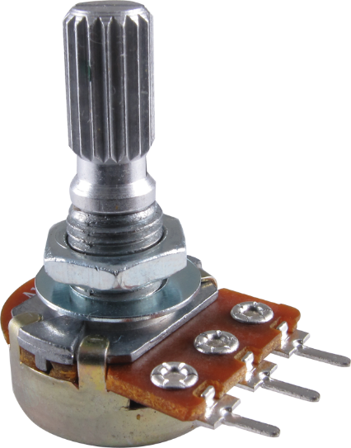

*Figure 2.4 Potentiometer*

In this project, we are going to use potentiometer in order to ajust frequency of our broadcast. We will connect the potentiometer through an analog pin on Ardunio board and we will map the possible variables of potentiometer to 88-108 FM gap.

**2.5 Voice Record Module**

In order to live broadcast through FM signals, we need a voice recorder which is able to record user’s voice and convert it analog audio signals for using in Ardunio. For that reason, ISD 1820 Voice Recorder Module is perfect for our project.

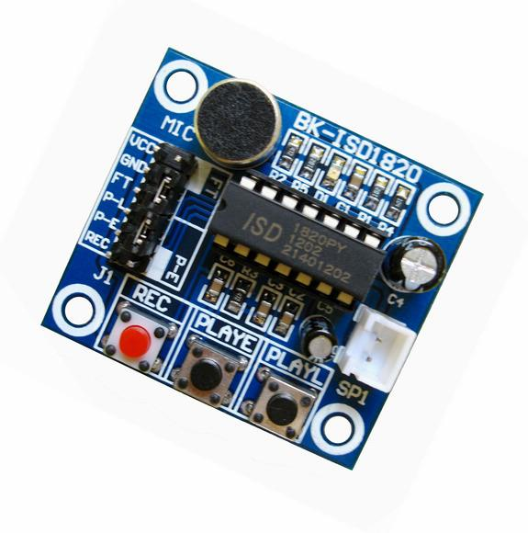

*Figure 2.5 ISD 1820 Voice Recorder Module*

Voice Record Module is base on ISD1820, which a multiple‐message record/playback device.It can offers true single‐chip voice recording, no‐volatile storage, and playback capability around 10 seconds. This module is easy to use which you could direct control by push button on board or by Microcontroller such as Arduino, STM32, ChipKit etc. From these, you can easy control record , playback and repeat and so on.

2.6 Code Explanation

#include "U8glib.h" // The library that we use in order to use Nokia 5110 LCD Display https://github.com/olikraus/u8glib/wiki/userreference

#include <FMTX.h> // The library we use in order to broadcast FM signals https://github.com/phrm/fmtx

U8GLIB_PCD8544 u8g(13, 11, 10, 9, 8); // In this line, we informed Ardunio about which pin from LCD Display connected to which pin on Ardunio

float channel=0;

float fm_freq = 88.0f; // Here set the default FM frequency

float reading=0; // A variable in order to keep track of potentiometer value

float last_reading=0; // The variable which holds the last value of potentiometer value

float Current_reading=0; // The variable which holds the current potentiometer value

float mapping_reading=0; // A variable created in order to save value after mapped from potentiometer value (0-1023) into frequency limits (88-108)

}

void setup(void){

pinMode(A0,INPUT); // Setting Analog 0 pin of Ardunio to get input from potentiometer.

Serial.begin(9600); // Starting serial monitor

fmtx_init(fm_freq, USA); // Initial FM Configuration. We gave fm_freq parameter which equals 88 initially and we selected USA as area

u8g.setRot180(); // Setting up the rotation of screen 180 which is horizontal

u8g.setColorIndex(1); // Parameter 1 means set pixel, parameter 0 means clear pixel

//..........................................

u8g.firstPage(); // Launching the first page

do{

set_screen(1);

}

while(u8g.nextPage() );

delay(1000);

//....................

u8g.firstPage();

do{

set_screen(0);

}

while(u8g.nextPage() );

delay(1000);

Clear();

//..........

u8g.firstPage();

do{

projectname(); // calls the function which shows project name

}

while(u8g.nextPage() );

delay(2500);

u8g.firstPage();

do{

author(); // calls the function which shows the author :)

}

while(u8g.nextPage() );

delay(2500);

Clear();

//..........................................

}

// Reading Any Tunning change here.

void Analog_pin_read(){ // A function which builded in order to read the the data through Analog 0 pin. Which means from potentiometer

Current_reading=channel;

fmtx_set_freq(channel-2); // Set new frequency

}

void set_screen(int i){

u8g.setColorIndex(i); // pixel on !

for (int x_axis=0;x_axis<84;x_axis++){

for (int y_axis=0;y_axis<44;y_axis++){

u8g.drawPixel(x_axis,y_axis);

}

}

}

void Clear(void){ // A function which clears the screen

u8g .setFont(u8g_font_04b_03);

u8g.setFontRefHeightExtendedText();

u8g.setDefaultForegroundColor();

u8g.setFontPosTop();

}

void projectname(void){ // The function which shows the name of the projects

u8g.setColorIndex(1);

u8g .setFont(u8g_font_osr18);

u8g.drawStr( 7, 25, "Radio");

u8g .setFont(u8g_font_unifont);

u8g.drawStr( 0, 40, " Emergency");

}

void author(void){ // The functions which shows the name of author

u8g.setColorIndex(1);

u8g.drawFrame(0,0,83,47);

u8g .setFont(u8g_font_04b_03);

u8g.drawStr( 2, 7, " ");

u8g.drawStr( 15, 15, "Prepared by:");

u8g.drawStr( 20, 26, "ILKER UNAL");

}

//change frequency value On lcd here

void number(float value){

u8g.setColorIndex(1);

u8g.drawFrame(0,0,83,47);

u8g .setFont(u8g_font_04b_03);

u8g.drawStr( 5, 15, "Frequency ");

u8g .setFont(u8g_font_unifont);

u8g.setPrintPos(6,38);

u8g.print(value);

u8g .setFont(u8g_font_04b_03);

u8g.drawStr( 56, 38, "MHz ");

}

void loop(){

reading=analogRead(A0); // The variable which holds the value of the potentiometer that connected to Analog 0 input

mapping_reading=map(reading,0,1023,8800,10800); // map values between 0-1023 to 88-108

mapping_reading = mapping_reading / 100.0f; // Dividing 100 to get float frequency value

if( mapping_reading - Current_reading >= 0.2f || Current_reading - mapping_reading >= 0.2f ){ // detect changes of the frequency values

Clear();

Analog_pin_read();

u8g.firstPage();

do{

number(channel); // Sends the channel variable to number function and hereby we change the frequency

}

while(u8g.nextPage() );

delay(100);

}

}

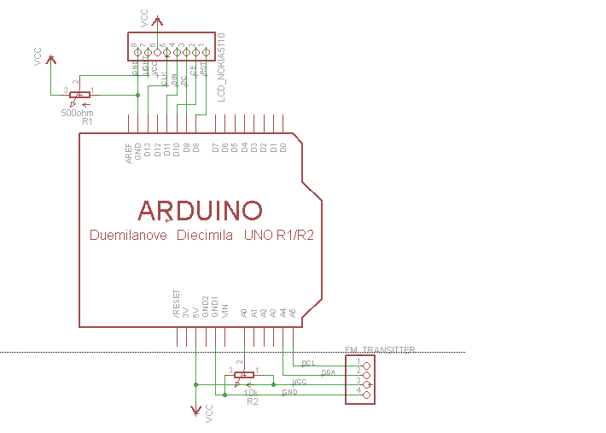

*Figure 2.6 Arduino Pin Diagram*

3. CONLUSION

During the development of the project, I’ve learned how to design an hardware according to project requirements. Hereby, I extended my knowledge on electronic components such as Arduino and understand that, the code has to be designed according to hardware, not visa versa.

With the solution I provide, I’ve proved that it’s easy to build a device with low costs which may bring more security in daily life.

REFERENCES

<https://github.com/olikraus/u8glib/wiki/userreference>

<https://www.allelectronics.com/mas_assets/theme/allelectronics/spec/ME-63.pdf>

<https://learn.sparkfun.com/tutorials/what-is-an-arduino>

<http://www.resistorguide.com/potentiometer/>

<https://components101.com/nokia-5110-lcd>

<https://github.com/phrm/fmtx>